Another word search!
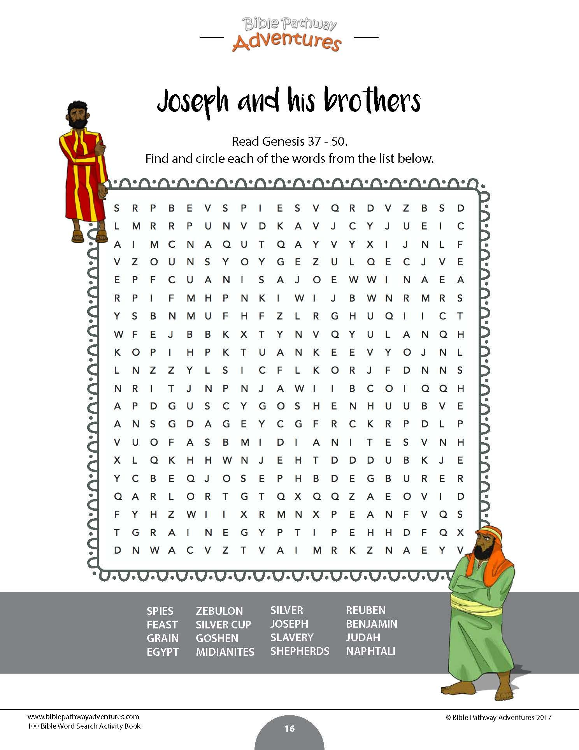

See if you can spot the differences between the two pictures . . .(there are at least 10!)

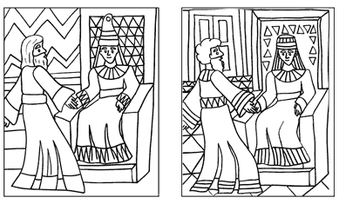

Joseph tells Pharaoh what his dreams mean – is it good or bad news?
