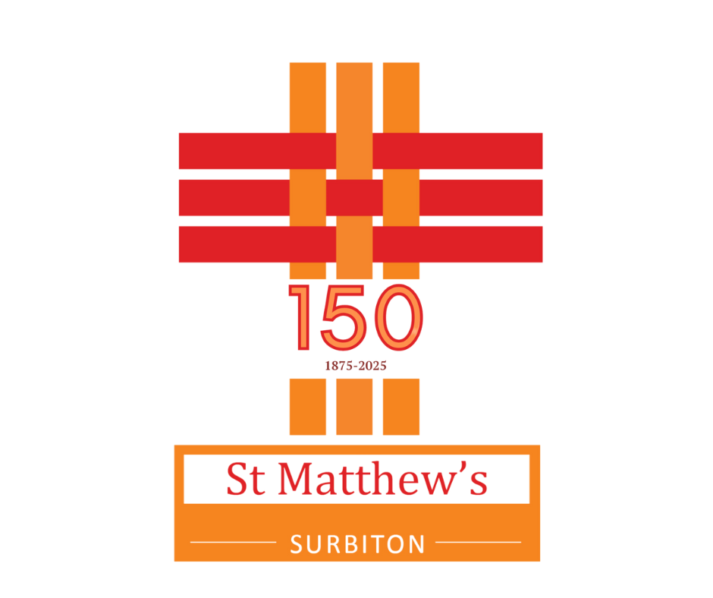
Parish of St Matthew,Surbiton in the Tolworth Hook & Surbiton Team Ministry
14th December 2025
Advent 3

 | Bible Readings  Isaiah 35.1-10  Matthew 11.2-11  Collect  O Lord Jesus Christ who at your first coming sent your messenger to prepare your way before you:  grant that the ministers and stewards of your mysteries may likewise so prepare and make ready your way by turning the hearts of the disobedient to the wisdom of the just, that at your second coming to judge the world we may be found an acceptable people in your sight; for you are alive and reign with the Father in the unity of the Holy Spirit, one God, now and for ever. Amen | 9am Hymns  Hark! A thrilling voice is sounding (sheet)  Hark, what a sound (sheet)  People, look east (sheet)  Thou didst leave thy throne MP 697 (omit vv 2 & 3)  Anthem: Christ is the truth - arr. John Barnard  Voluntary: Wake, Awake, for Night Is Flying - Paul Manz  Please Pray for  Southwark Diocese. Bishop Martin, Caroline, Carolyn, Nicholas, William, Jen, our clergy & THiS Team Ministry. Julie Martin, Rev. Janice Price, Mary Carter, Malcolm Beckett, Mark Curzon, Roy Smith, Jane Wood & their families.

 | This Week
 | Monday | 15 | 9am  9.45am - Noon  9.45am  7pm - 10pm | Morning Prayer: Chapel  Encore Choir Christmas event: Church  Brunch Bunch: Sitzler room  CornerHouse Playwrights group
 | Tuesday | 16 | 9am | Morning Prayer: Chapel
 | Wednesday | 17 | 9am  10am- Noon  7.30 pm - 9pm | Morning Prayer: Chapel  Bereavement Support group: Chapel  AA Support meeting: Sitzler Room
 | Thursday | 18 | 10am - Noon  6.30pm - 7.30pm | SMArties: Sitzler Room  Choir practice: Sitzler room/Church
 | Friday | 19 | 9.30am  11.30am | St Matthew’s School Christmas service: Church  Southborough High School Christmas service: Church
 | Saturday | 20 | 9am  9.45am - 12.15pm  5pm - 6pm | Morning Prayer: Chapel  Sing at St Matthew’s: Sitzler Room/Church  Blue Christmas: Church
 | Sunday | 21 | 9am  10.45am  6pm | Holy Communion  Worship together and Holy Communion for all ages and stages  Carol Service: Church

Fuel 2026
See CONNECT or posters for dates.

Cornerhouse Community Carols
Community Christmas carols Monday 15th Dec 6.15pm for a 6.30pm start. Join with singers and
musicians from St Matthew’s Church. Families especially welcome – come and go as you please. Free
admission, mulled wine and soft drinks.

Upcoming Events
24th 4pm Christmas Eve Come as you are Nativity- with Christingle kits to take away.
24th 11.15pm Midnight Mass
25th 9am Said Communion at the High Altar
25th 10.45 am Family Communion with Carols

KCAH - Urgent Request
The Winter Night Shelter provides five months of safety and security for up to 30 rough sleepers in Kingston. They are open every night from 7pm and offer a hot meal, an evening of community, a warm, comfortable bed and breakfast. If you would like to get involved in this amazing project as a volunteer either of your time or a home-cooked meal. Email winternightshelter@kcah.org.uk

Church Notices
If you have any notices for the weekly sheet, please contact the events@stmatthewskt6.org or use the online Event Form which is linked in the weekly email. If you do not have email please contact the Parish Office.
Contacts
Parish Office | Steve Blevins | admin@stmatthewskt6.org  On Leave until 05/01/26 If urgent ask Wardens/Caroline | 020 8390 5121
Team Rector | Rev. Caroline Kramer | teamrector@stmatthewskt6.org | 07707 785721
Team Priest | Rev. Carolyn Lucas | carolynlucas@gmail.com | 07933 022516
Director of Music | Mr. Jason Edge | music@stmatthewskt6.org

Safeguarding
Please contact Sue Fraser or Chris Taylor on 07895 501517 or to speak to someone in person if you have any Safeguarding concerns or questions. You can also ask Clergy or Wardens if the need is immediate.


Motto Verse 2025 –“ Be still and know that I am God”
Psalm 46 v10

